

**Online learning**

**Software Requirement Specification**

**Team 2**

– Hanoi, Feb 2023 –

Record of changeS

|  |  |  |  |
| --- | --- | --- | --- |
| Date | A* M, D | In charge | Change Description |
| 28/1 | A | ThanPM | Add screen flow (I.2.a) |
| 01/02 | A | ThangPM | Update screen flow (I.2.a), screen details (I.2.b) |
| 08/02 | A | ThangPM | Add introduction (I.1), screen details (I.2.b), User Authorization (I.2.c) |
| 13/02 | A | ThangPM | Add erd (I.3), functional requirements (III) |
|  |  |  |  |
|  |  |  |  |
|  |  |  |  |
|  |  |  |  |
|  |  |  |  |
|  |  |  |  |
|  |  |  |  |
|  |  |  |  |

*A - Added M - Modified D - Deleted

**Table of Contents**

I. Overview 4

1. Introduction 4

2. System Functions 5

3. Entity Relationship Diagram 6

II. Functional Requirements 7

1.Public Feature 7

a.Home Page 7

b.Pop up 7

c.News ………………………………………………………………………………………………………………………………………

d.Class………………………………………………………………………………………………………………………

e.Course………………………………………………………………………………………………………………………

g.Payment………………………………………………………………………………………………………………………

h.Payment Page………………………………………………………………………………………………………………………

i.Support Center………………………………………………………………………………………………………………………

2. Common Feature 7

1. User Login………………………………………………………………………………………………………………………
2. User Profile………………………………………………………………………………………………………………………
3. Change Password…………………………………………………………………………………………………
4. User Register…………………………………………………………………………………………………

# I. Overview

## 1. Introduction

This project is aimed at Online Learning system which supports for students and parents finding the most suitable course which are maths, literature,

English, ... All of this course is very easy to use and learn, it has learning-game so the students find it interesting to learn.

## 2. System Functions

#### a. Screen Flow

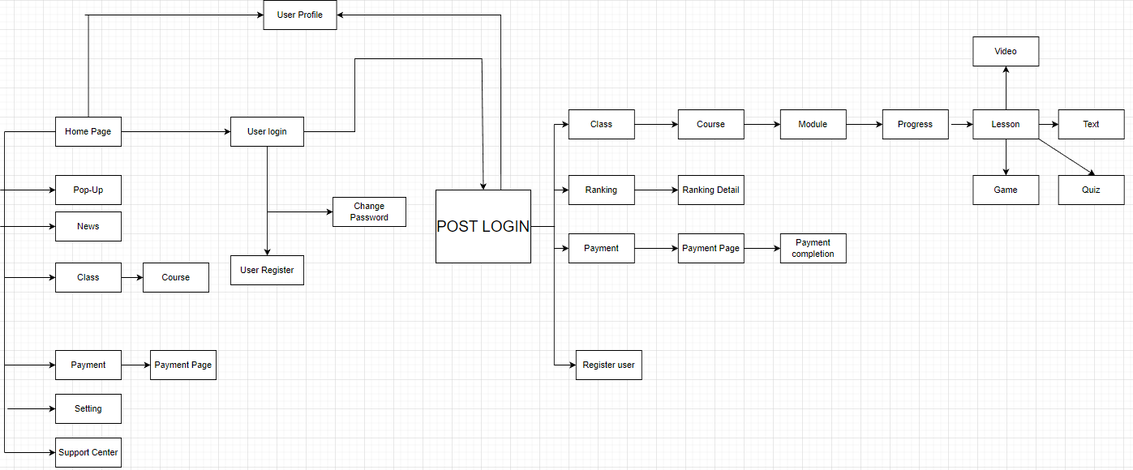

#### b. Screen Details

|  |  |  |  |
| --- | --- | --- | --- |
| **#** | **Feature** | **Screen** | **Description** |
| 1 | Public | Home Page | -Show navigation bar:Home,Ranking,Class,Payment,Setting,Profile,Support Center  -Show the newest information which are about notification of courses,update news about education,change of the web,premium account,…  -Show the advertisement of course in web |
| 2 | Public | Pop-Up | -Show the notification to user |
| 3 | Public | News | -Show navigation bar:Home,Ranking,Class,Payment,Setting,Profile,Support Center  -Show the detail of the news to the user  -Show the advertisement of course in web |
| 4 | Public | Class | -Show navigation bar:Home,Ranking,Class,Payment,Setting,Profile,Support Center  -Show all of the class from grade 1 to grade 5  -User can choose the suitable class that they want to learn |
| 5 | Public | Course | -Show navigation bar:Home,Ranking,Class,Payment,Setting,Profile,Support Center  -Show all of the course of the class (Maths,Literature,English)  -User can choose one of three subjects to learn |
| 6 | Public | Payment | -Show navigation bar:Home,Ranking,Class,Payment,Setting,Profile,Support Center  -Show feature of normal account and premium account  -User can choose to register normal or premium account |
| 7 | Public | Payment Page | -Show navigation bar:Home,Ranking,Class,Payment,Setting,Profile,Support Center  -Show the payment method and premium account detail  -User will fill the information of credit card(number of card,date,pass) |
| 8 | Public | Support Center | -User can ask question via email, phone or send messages |
| 9 | Common | User Login | -This screen allows user to login with username, after login user redirect to Home page |
| 10 | Common | User Profile | -This screen allows user to edit his/her profile information(include full name,email,phone number,address) |
| 11 | Common | User Register | -This screen allow user to regist their account by fill the username,password and repassword  -User should create account in the right way |
| 12 | Public | Setting | -This screen allow user can change audio,change password,log out |
| 13 | Common | Module | -This screen show all lesson of the subject that user can pick to learn |
| 14 | Common | Progress | -This screen show the progress percent user have learnt |
| 15 | Common | Lesson | -This screen show the content(include video) and exercise(include quiz,games) |
| 16 | Common | Ranking | -This screen show ranking point of subject(sort to high to low point of subject) |
| 17 |  |  |  |
| 18 | Common | Payment completion | -This screen notifies to user that user have completely signed up premium account |
| 19 | Admin | Register user | -This screen allow admin to manage all account(include normal and premium)  -If users have problem with their account, users can contact with admin via support center |

#### c. User Authorization

|  |  |  |  |  |
| --- | --- | --- | --- | --- |
| Screen | Guest | Normal User | Premium User | Admin |
| Home Page | X | X | X |  |
| Pop-Up | X | X | X | X |
| News | X | X | X | X |
| Class | X | X | X | X |
| Course | X | X | X | X |
| Module |  | X | X | X |
| Progress |  | X | X |  |
| Lesson |  | X | X | X |
| Payment | X | X | X |  |
| Payment Page | X | X | X |  |
| Payment Completion |  | X | X |  |
| Support Center |  | X | X |  |
| User Profile |  | X | X |  |
| User Login |  | X | X |  |
| User Register |  | X | X |  |
| Change Password |  | X | X |  |
| Ranking |  |  | X |  |
| Ranking Detail |  |  | X |  |
| Setting | X | X | X | X |
| Register User |  |  |  | X |

In which:

-Admin: the organization leader/manager, acts as the system administrator

-Customer: + Parents: They are registered users who find the system, choose and register for their childrens

+Students: They are users who experience and use the system. This is potential customers

-Guest: Unregistered users

#### d. Non-Screen Functions

|  |  |  |  |
| --- | --- | --- | --- |
| **#** | **Feature** | **System Function** | **Description** |
| 1 | Common | User Authentication | the specify the role of logged-in user, his/her authorized page links (building the displayed menu items (in the front end) and preventing unauthorized access via enter the links directly) |
| 2 |  |  |  |

## 3. Entity Relationship Diagram

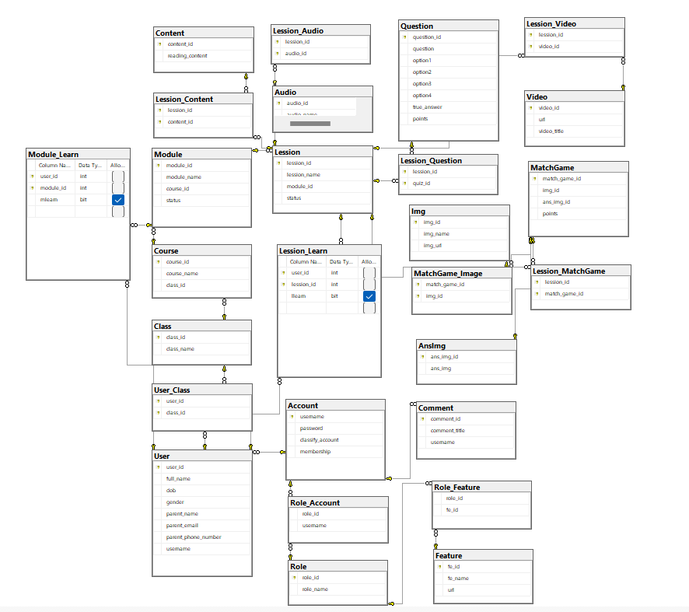

# II. Functional Requirements

## 1. Public Feature

a.Home Page:

* Function trigger: Direct access via link: “#” or after login by email
* Function description:
  + Customer and Guest roles will have access to this screen
  + This screen show navigation bar to navigate to other screens/functions
  + This screen show news,pop-up,advertisement

Screen layout:

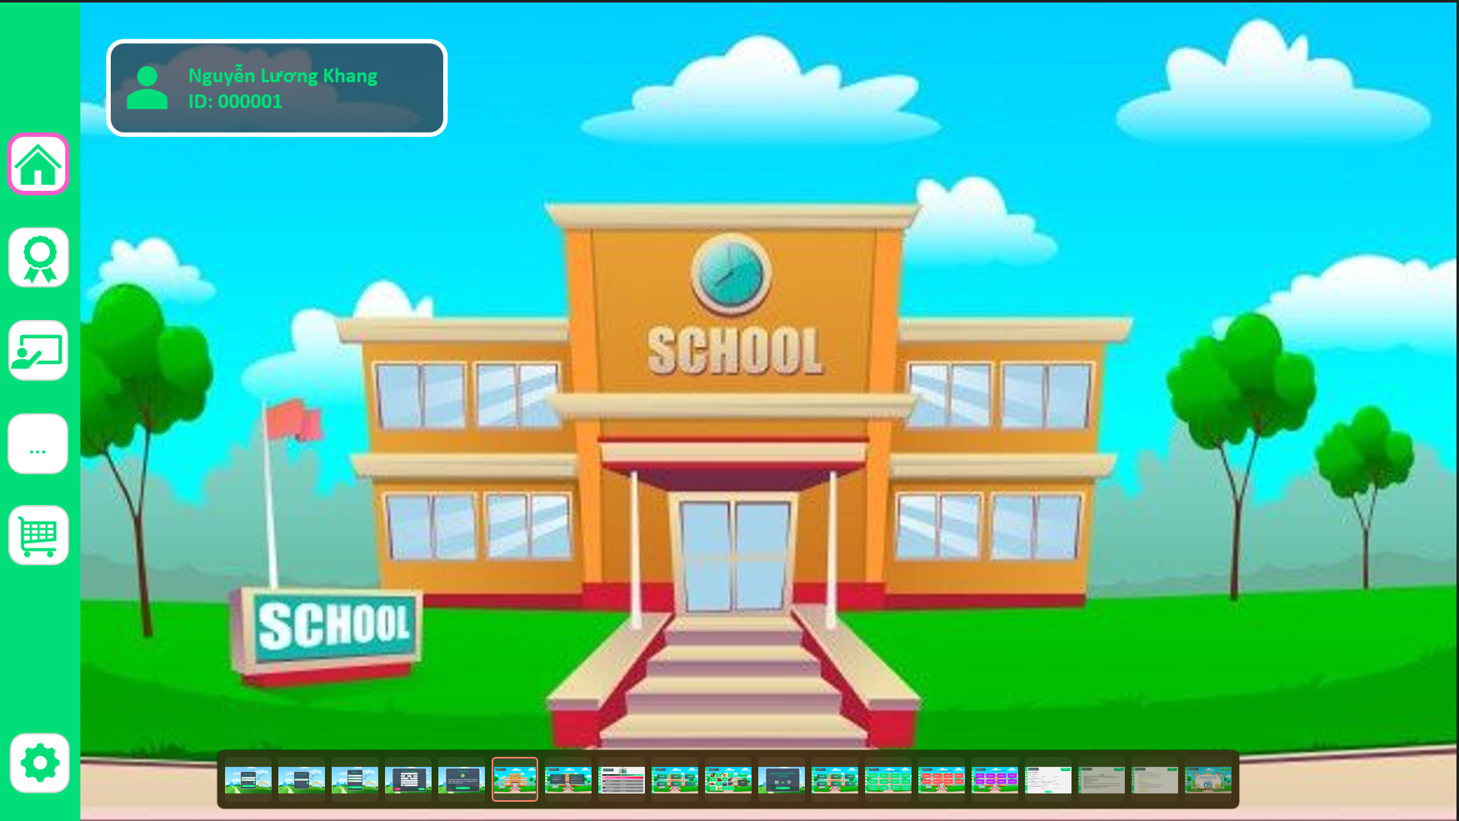

b.Pop-Up:

* Function trigger: Automation appear when user go to Home Page
* Function description:
  + Customer and Guest roles will have access to this screen
  + This screen show the hottest news or the important notification to user

Screen layout:

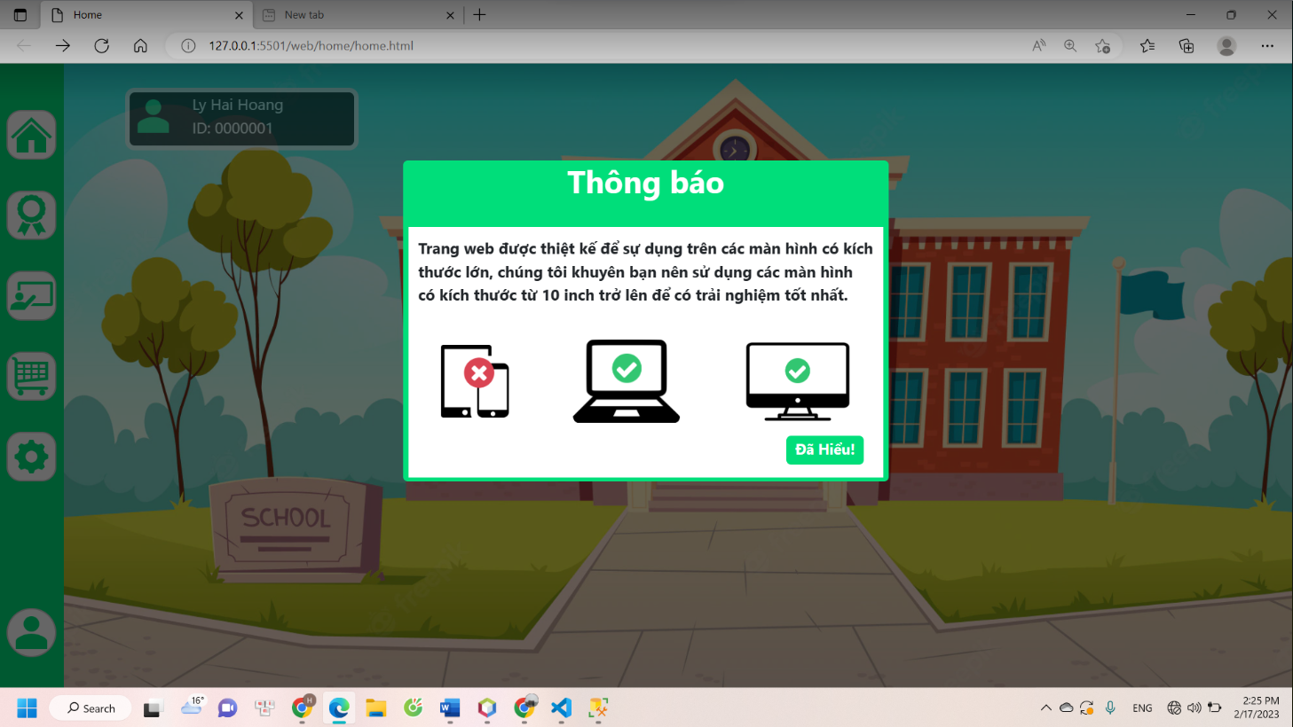

c.News:

* Function trigger: User can see News in Home Page and click to the News to see the detail of News
* Function description:
  + Customer and Guest roles will have access to this screen
  + This screen show the information of educating in web and important of information about the web

d.Class:

* Function trigger: When user click to CLASS on navigation bar
* Function description:
  + Customer and Guest roles will have access to this screen
  + Show all of the class from grade 1 to grade 5
  + User can choose the suitable class that they want to learn

Screen layout:

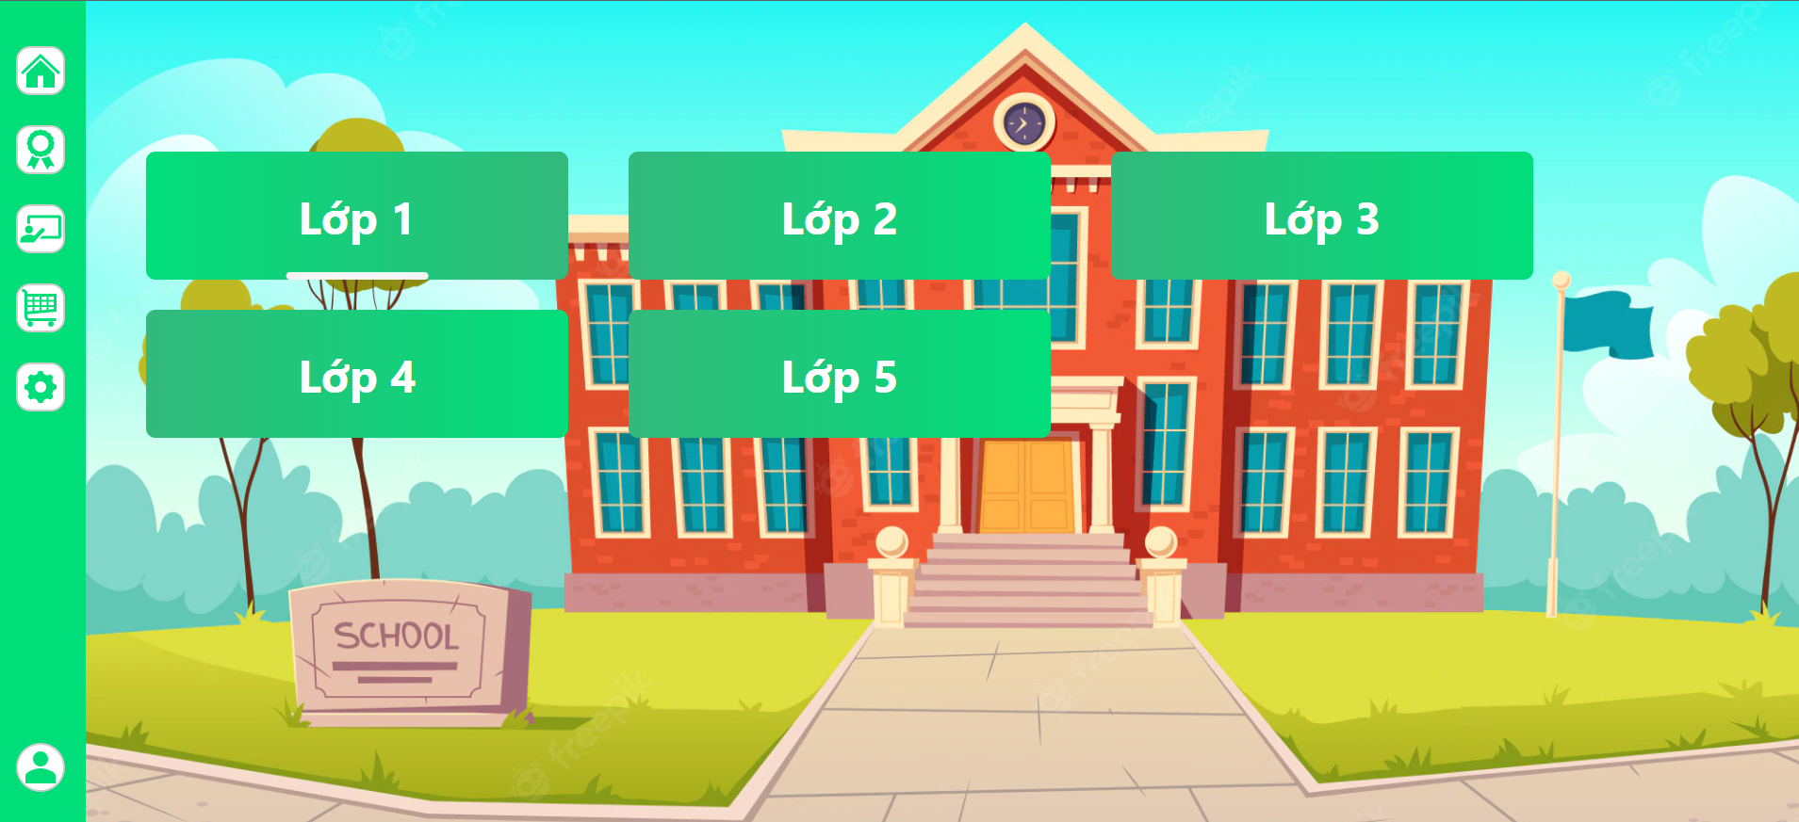

e. Course:

* Function trigger: When user click to CLASS on navigation bar and choose their class
* Function description:
  + Customer and Guest roles will have access to this screen
* Show all of the course of the class (Maths,Literature,English)
* User can choose one of three subjects to learn

Screen layout:

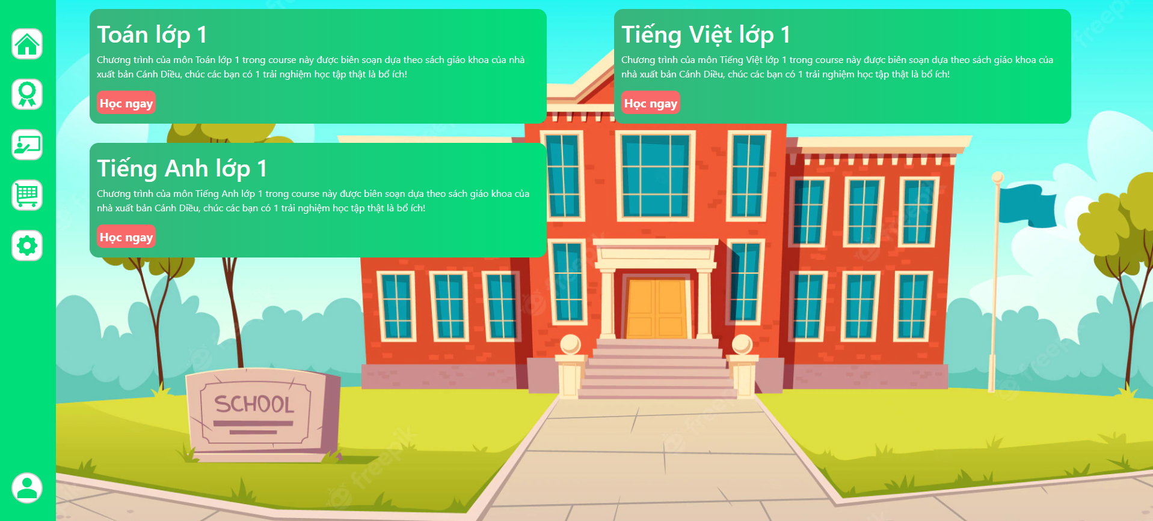

f. Payment:

* Function trigger: When user click Payment on navigation bar
* Function description:
  + Customer and Guest roles will have access to this screen
* Show the advantages of normal account and premium account
* Customer can click Premium account to upgrade their account

Screen layout:

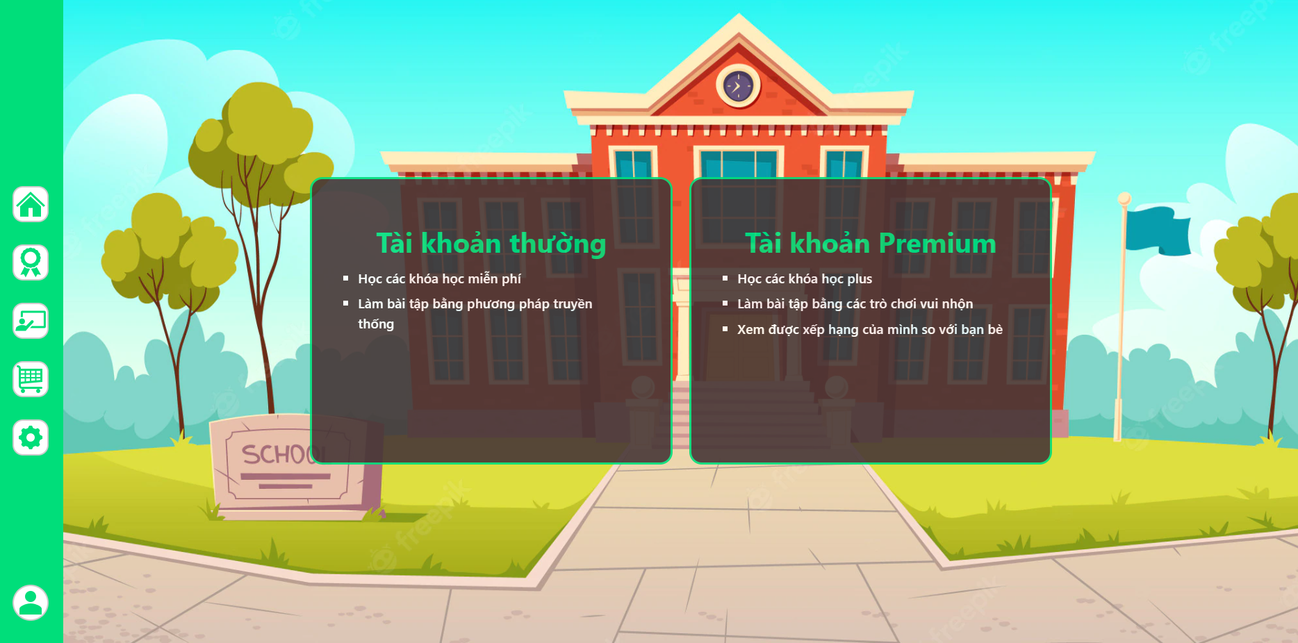

g.Payment Page:

* Function trigger: When user click Payment and choose Premium Account
* Function description:
  + Customer and Guest roles will have access to this screen
* This Page show a bill which has the advantages of premium account and the detail of payment method(credit and debit card)
* User can choose the card they want to pay and fill their card number , date and pass

Screen Layout:

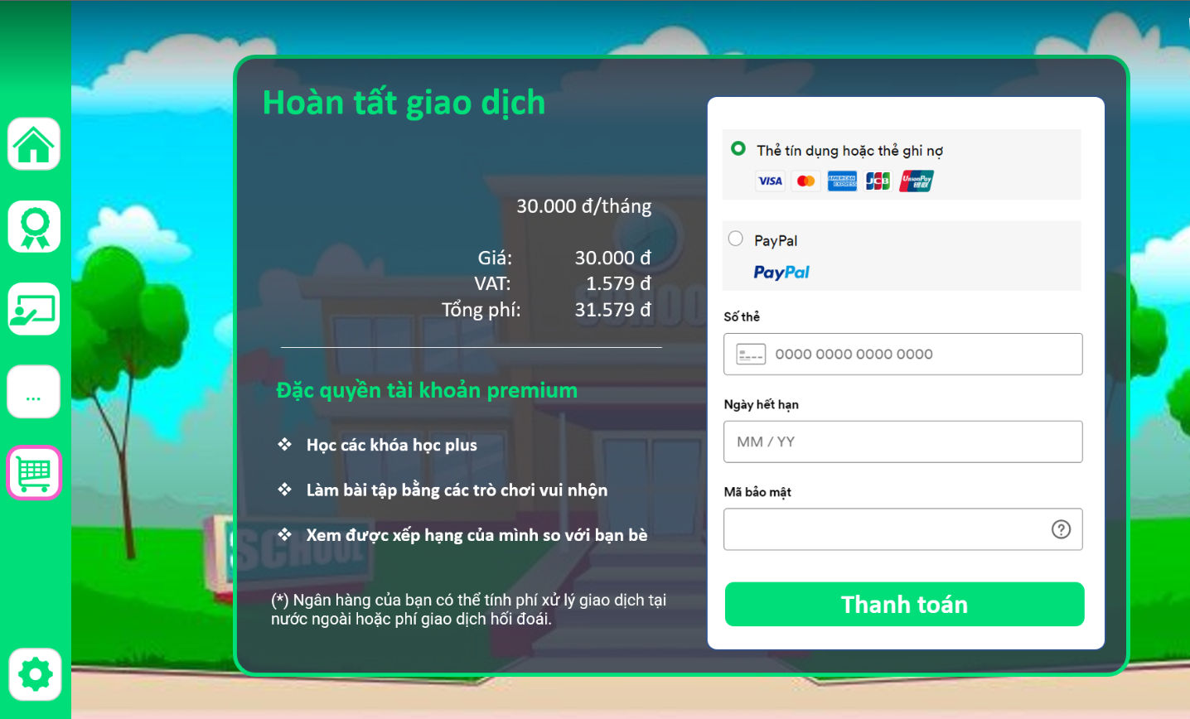

h.Support Center:

* Function trigger: When user click Support Center in Home Page
* Function description:
  + Customer and Guest roles will have access to this screen
* Show the email and phone number for user to contact with admin
* Admin can help user solve the problem or answer their question about the web

2. Common Feature:

a.User Register:

* Function trigger:When user click to Sign in ,if user don’t have account, user click sign up
* Function description:
  + Customer and Guest roles will have access to this screen
* Show username,password and re-password
* User need to fill this sign up to have an account

Screen layout:

b.User Login:

* Function trigger: User click sign in
* Function description:
  + Customer roles will have access to this screen
* Show username and password
* User need to fill their account to join

Screen layout:

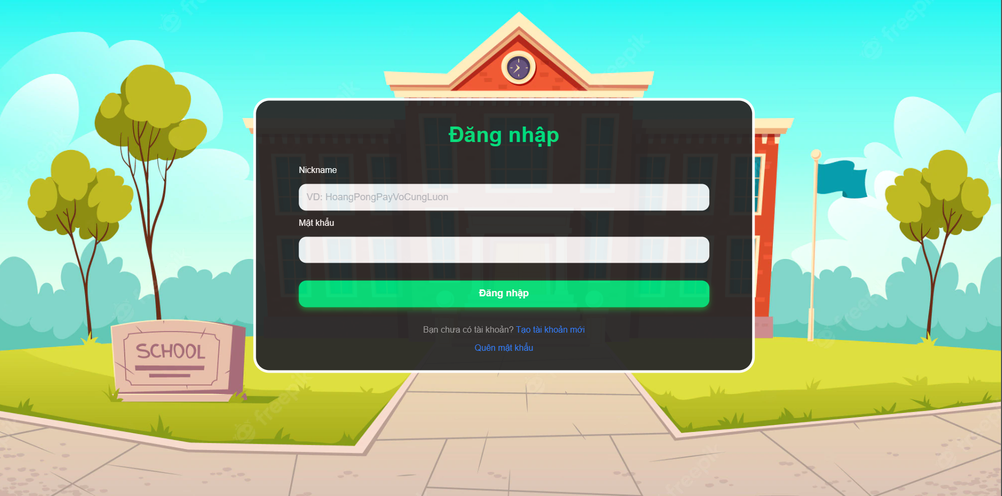

c.User Profile:

* Function trigger: When user click User Profile in navigation bar
* Function description:
  + Customer roles will have access to this screen
* Show their information(include email,phone number,address)
* User can change their profile

d.FOrget PassWord:

* Function trigger: When user click User Profile in navigation bar
* Function description:
  + Customer roles will have access to this screen
* Show their information(include email,phone number,address)

Screen layout:

